1. Blood bank admin:
2. Enter password : hacked.



1. Main blood bank admin window

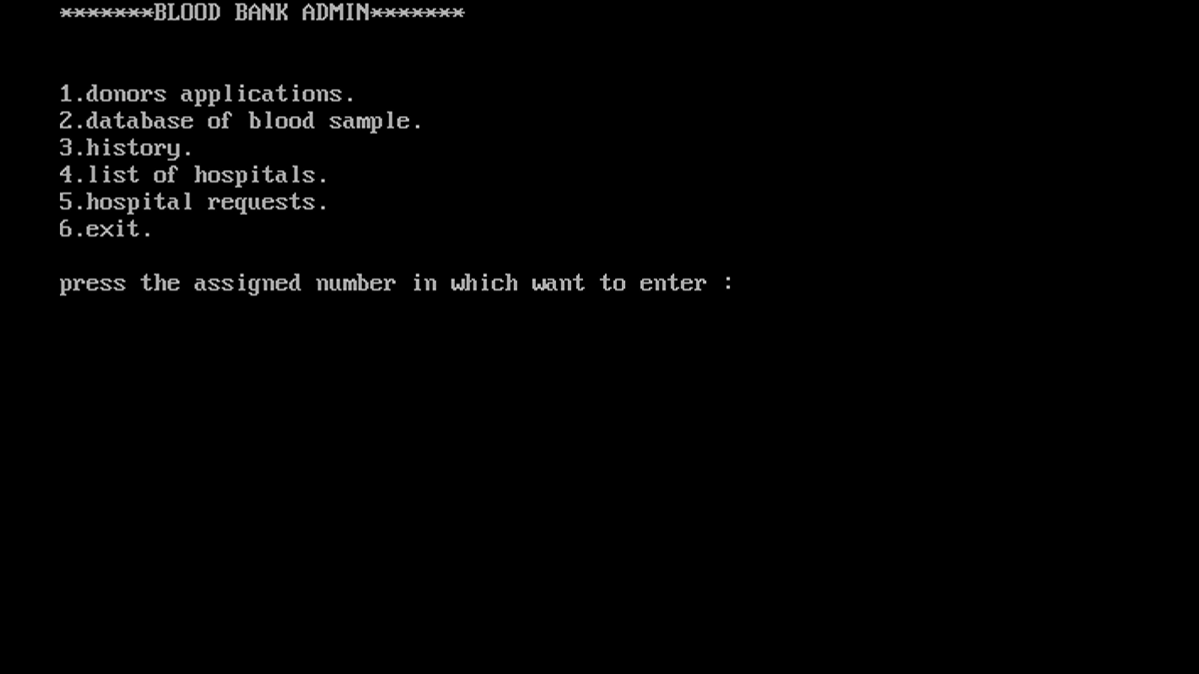

1. Donor applications
2. Accepting and entering the date when accepted

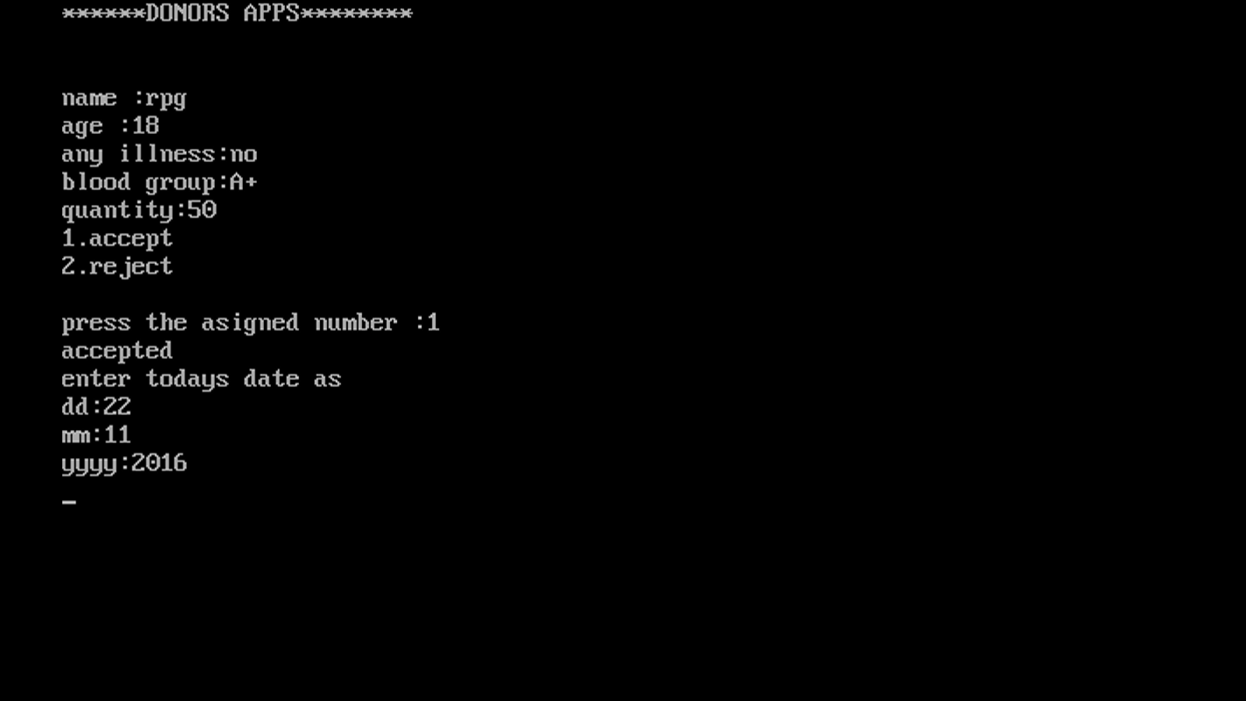

1. rejecting

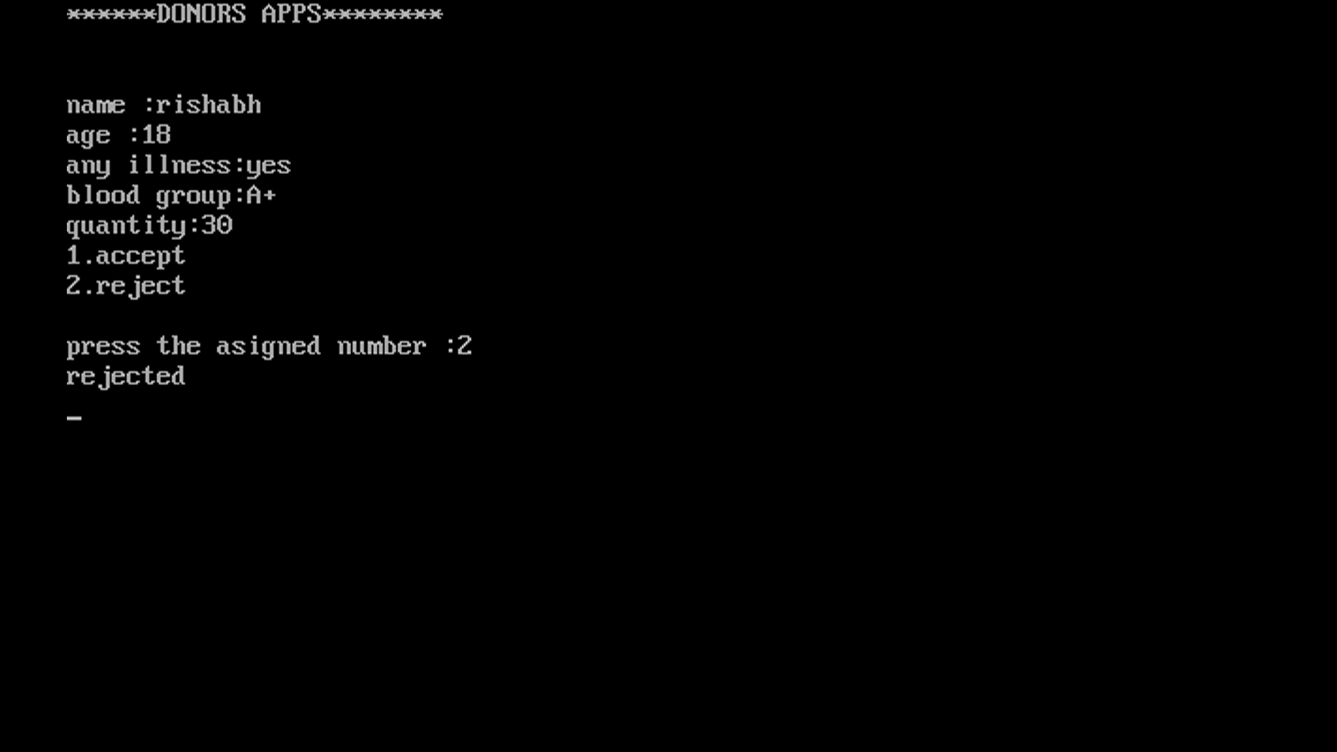

1. no more applications remaining



1. Database of donors whose applications are accepted

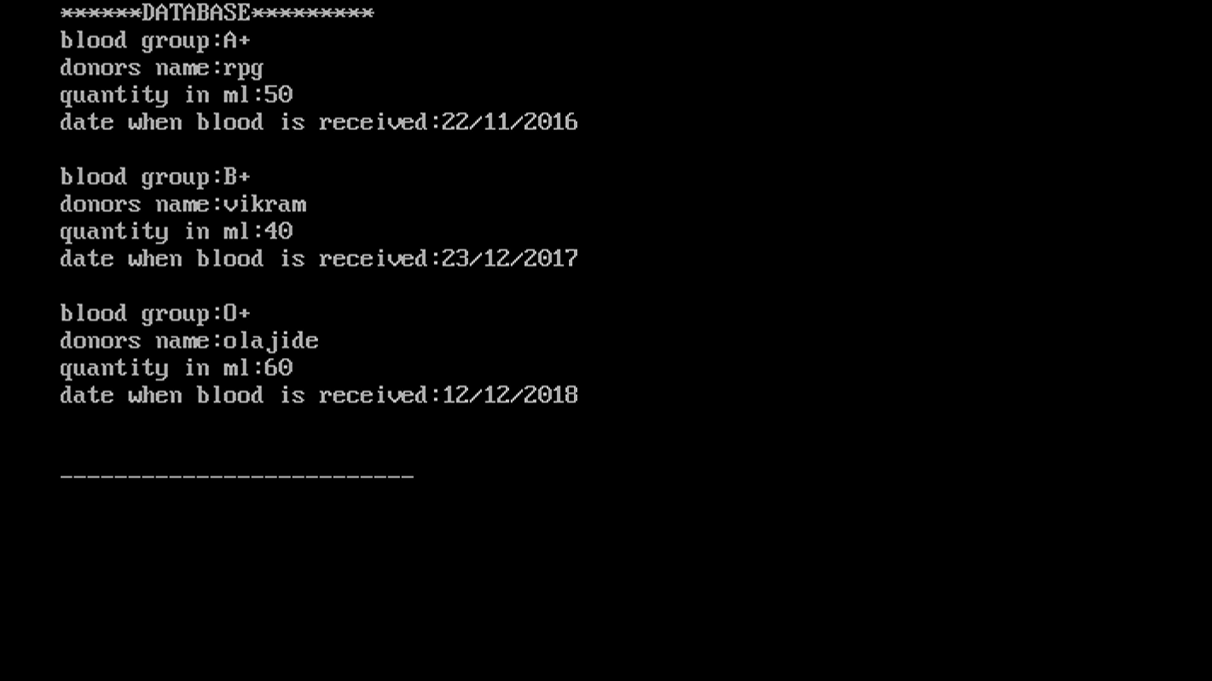

1. History (at which date, which blood group and how much quantity is given to the hospitals)

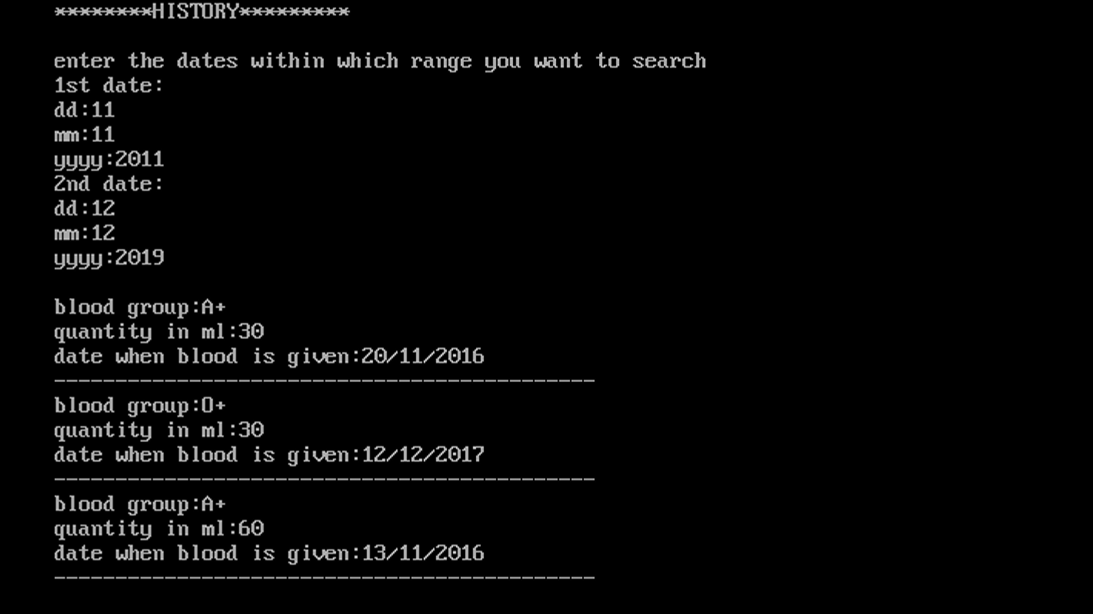

1. List of Hospitals main window



1. 1.View list of hospitals

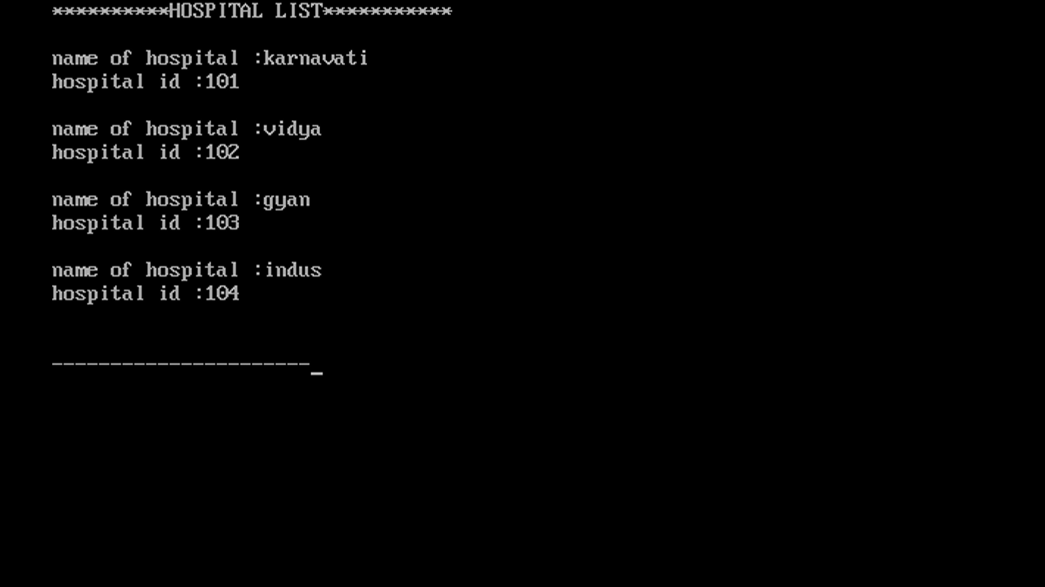

1. 2.Updating name of hospital by providing hospital id

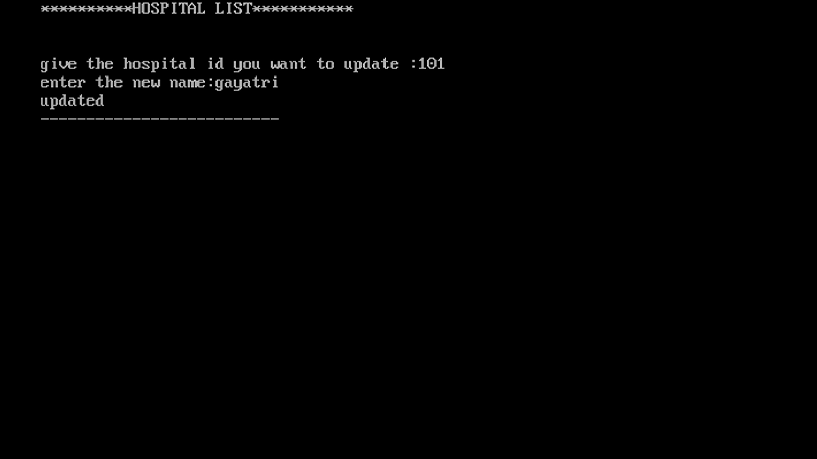

(viewing the updated list)

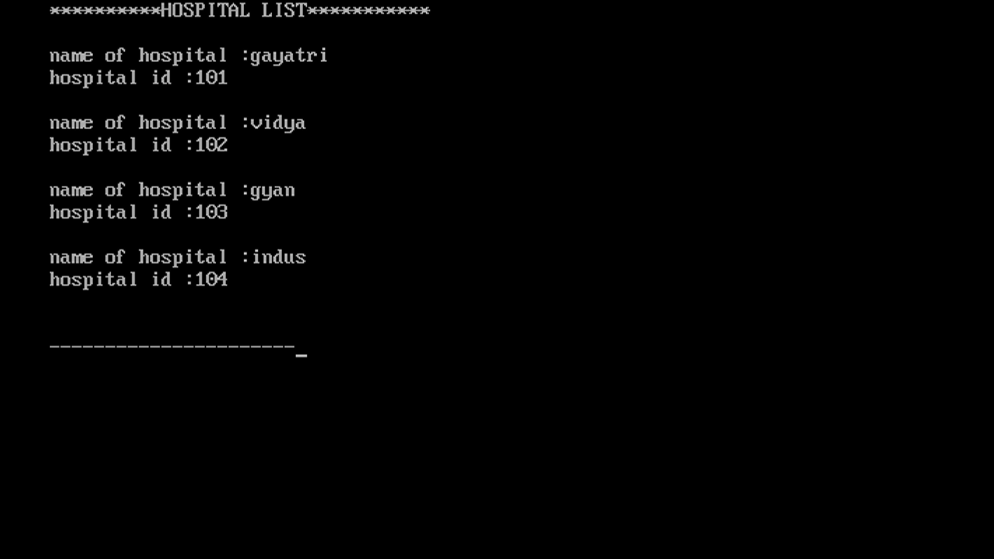

1. 3.deleting hospital by providing id

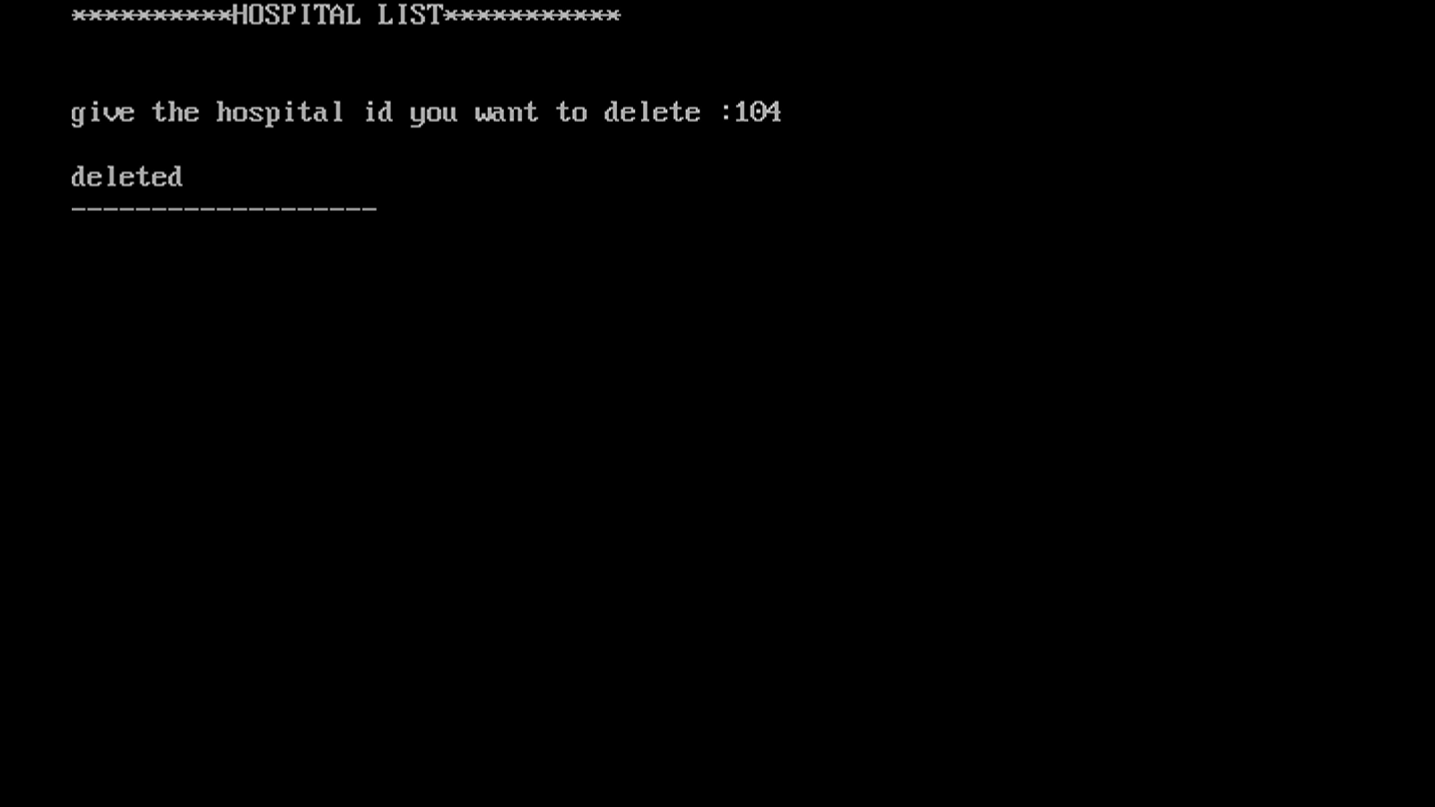

(viewing the list after deleting)

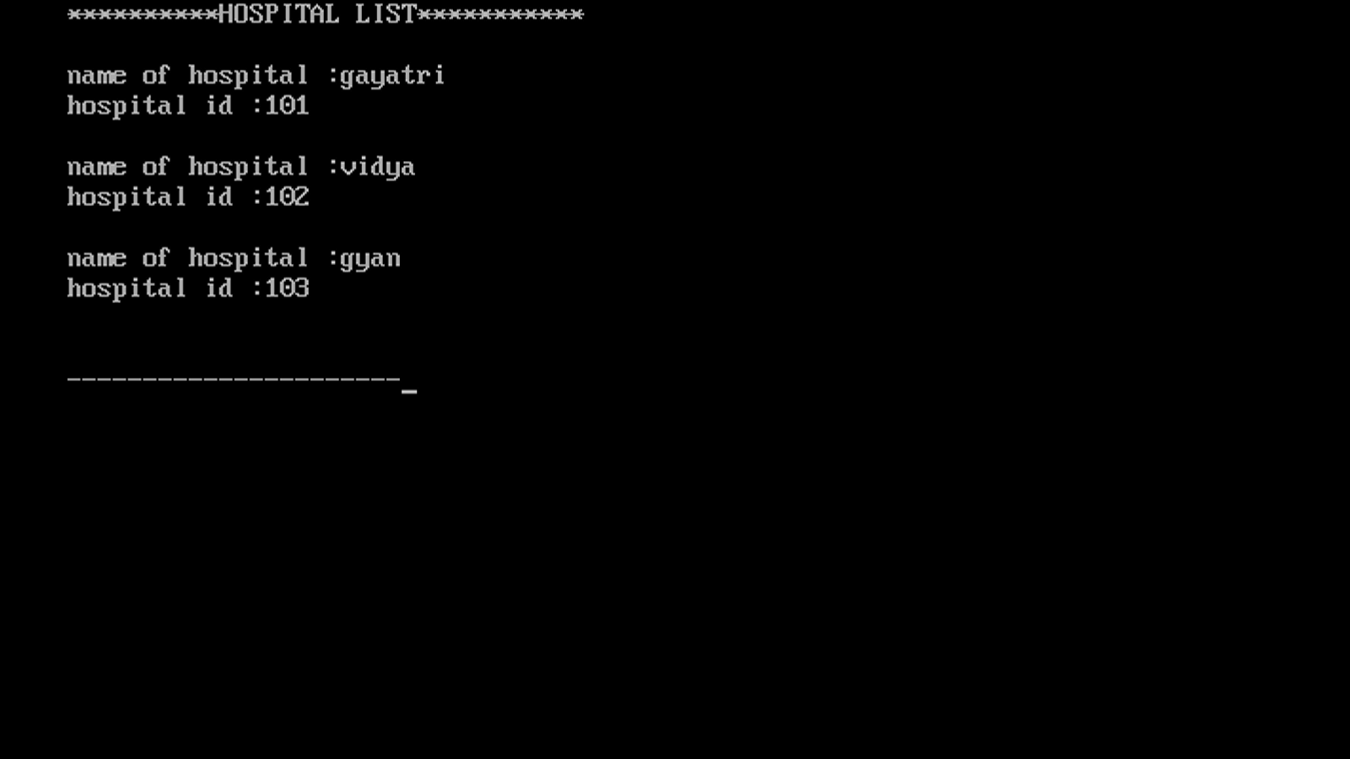

1. Hospital request
2. Accepting the request and writing when it is accepted

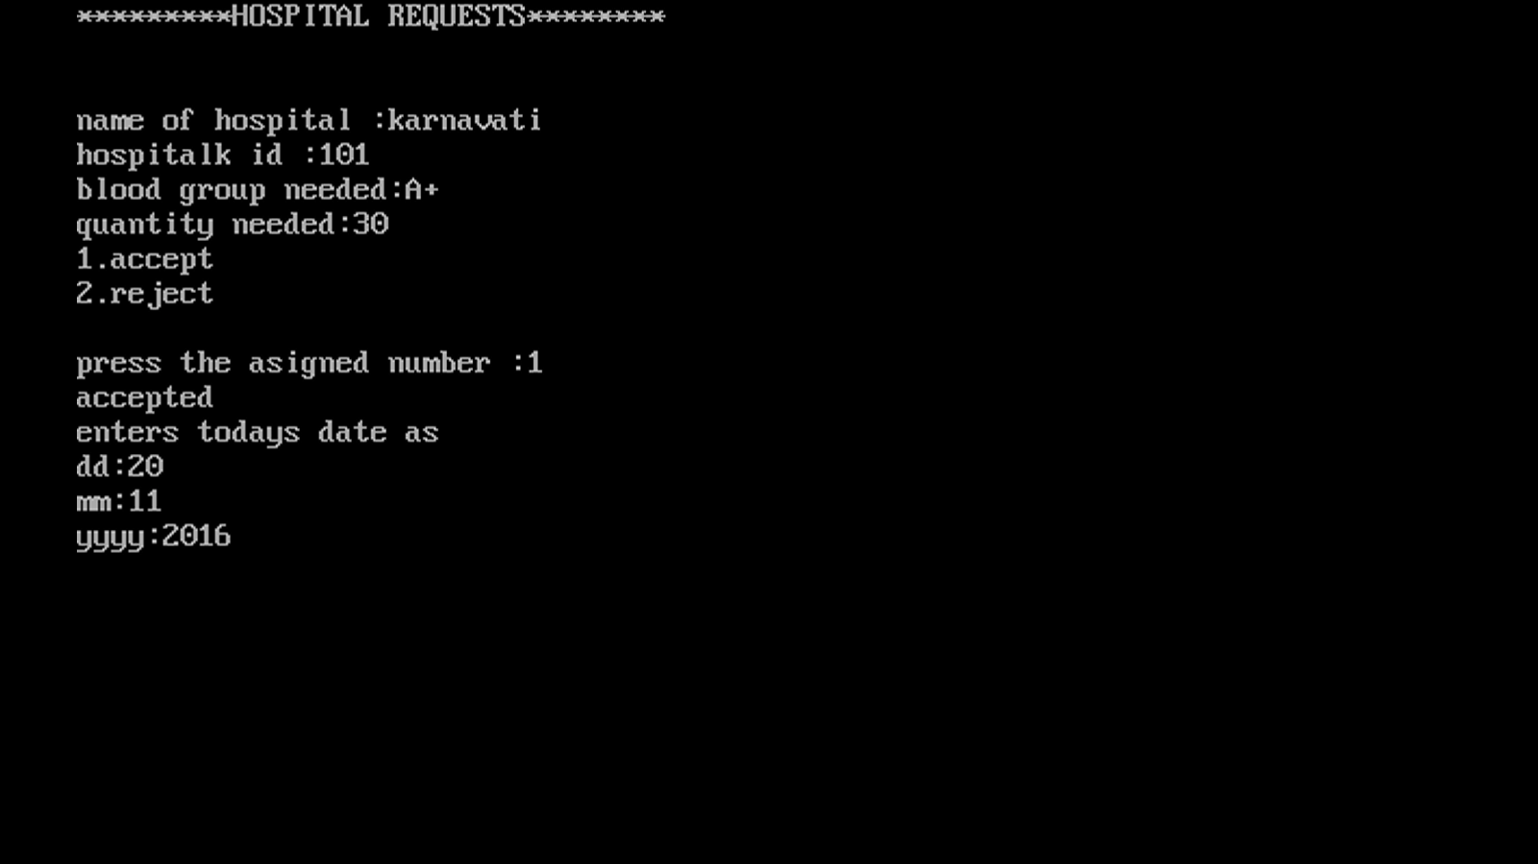

1. Rejecting a request

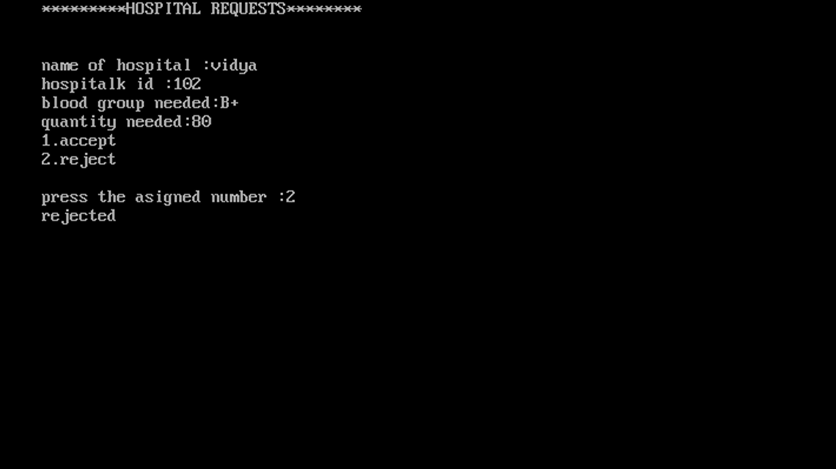

1. No more requests remaining

